Ms. Harper’s English 10 Course Expectations and Procedures

Contact Information
Teacher Name: Kirsten Harper Room: R-8 Email: kharper@srvusd.net

Potential Texts
Lord of the Flies, William Golding Macbeth, William Shakespeare
Animal Farm, George Orwell The Joy Luck Club, Amy Tan
Excerpts from Malcolm Gladwell’s writing Supplemental stories, articles, poems

Course Description
English 10 is a college preparatory language arts course that expands and strengthens the skills developed in English 9. This course emphasizes composition, critical reading, and collaborative speaking skills. Students will study poetry, short story, drama, non-fiction, and novels. The course also includes writing instruction, focusing on argumentation and informative/explanatory texts. Students will also develop skills in research, digital media, and vocabulary acquisition and use.

Expectations
- First and foremost, our classroom will be a safe community that promotes free thinking and learning. Everyone is expected to treat others with respect.
- I expect you to be on time and to walk-in prepared to learn. Every day we will begin with a warm-up activity, and you will be expected to come in, take out your notebook, and begin the warm-up. In this class we will do a lot of projects and writing, but I do my best to give you plenty of class time to work on these things. I ask for 55 minutes of engagement every day, and in return your homework should generally be light. Simply put, if you waste class time, you will have more homework.
- Ultimately, my goal for the year is that students will leave this class being able to think critically and form a claim about a given topic; defend that claim through clear, coherent writing; and share that claim with others, while staying open to differing opinions and respectful of opposing viewpoints.

Specifics
- This year, all of my sophomores will be maintaining a blog. This blog will be a platform for students to publish their written work in a medium suited for sharing with others. We will set up the blog in class and will continually visit the computer lab to work on the blog throughout the year. Details on exactly what to post and when will come in chunks, but maintaining this blog and staying on top of the writing is crucial to success in this class. Hold yourself to high standards while completing these assignments, and at the end of the year you will have an excellent catalog of your writing from this class.
- Additionally, every Tuesday we will do a “Tuesday Write,” where you will respond to a prompt in your notebook. The topics of these written responses will vary and will be posted on School Loop every week. If you are absent on a Tuesday, you are still responsible for the Tuesday write. These drafts will be graded as part of your notebook. Once a month, you will choose ONE Tuesday Write from that month to edit and post on your blog. This is a chance to practice full process writing, taking a piece from a rough draft to something worth sharing with the world.
- Finally, every Monday we will do outside reading in class. Each quarter you will read a new book according to the specifications for the corresponding assignment. First quarter you will read a fiction book and write a book review. Details on the assignment are forthcoming, but you need to have the book in class on Monday Sept. 9.

Materials
A notebook for daily warm-ups and journal writes. This must be a bound journal (spiral or composition are both fine) reserved ONLY for English and must be with you every day. I will collect it periodically to grade. See me if you need help getting a notebook.
Assigned novels and outside reading. You will be given school copies of the novel we are reading, or you may use your own. You are expected to bring these books to class every day. Also, we will be doing outside reading every week (one book per quarter), so you need to have an outside reading book. I will give you info on the specifications each quarter, and you may either get your book from the library, or purchase your own copy. You are welcome to bring electronic copies (Kindle, iBooks, etc).

Grading
Grades will be posted on School Loop. If you want to discuss your grade, see me to set up an individual time to talk. Each assignment will be worth a set number of points, and will fall into one of the following categories:
- Homework (15%), work done at home.
- Classwork/Participation (10%), in-class assignments, as well as bringing materials to class and participating in class discussions and activities.
- Tests/Quizzes (15%), mostly on vocabulary, grammar, and the novels we read. They will often be corrected in class, and then entered in the grade book.
- Writing and Essays (25%), Tuesday writes and major writing assignments. This category is a big one, and much of your writing will be published on your blog.
- Projects and Presentations (25%) will be a combination of classwork and homework. These assignments will often be on your Outside Reading book each quarter.
- Final Exam (10%) will be a cumulative final based on what we cover this semester.

Classroom Rules and Procedures
At the beginning of class, a warm-up will be on the board. You should come in, get out your notebook, and begin the warm-up quietly at the bell. If you are not in the classroom when the bell rings, you are tardy. See the SRVHS Attendance Policy for tardy consequences.

- 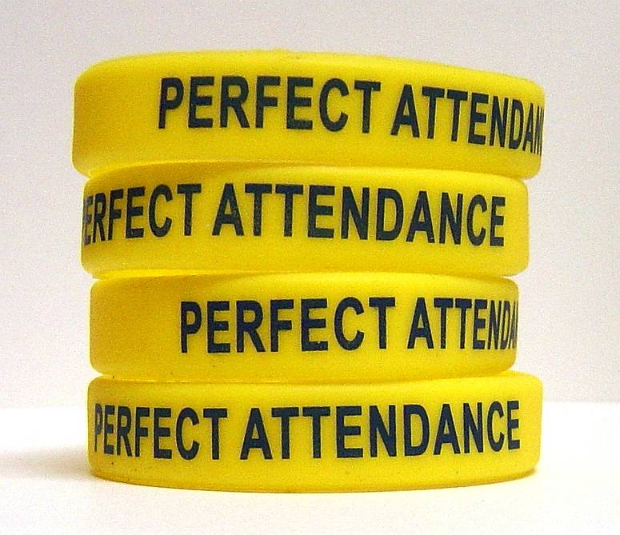
If you are absent, check School Loop. When you return, check the absent student file for any work you missed. You have up to three days to makeup missed work for an excused absence. It is your responsibility to turn that work in! Even if I don’t remind you, the work is still due. If you miss a test, it is your responsibility to set up a time with me to make it up, either before school or at lunch.
Late work cannot receive full credit. Late assignments receive a 50% at best.

Plagiarism is not tolerated. Do not copy anyone else’s work. If it becomes apparent that an assignment has been plagiarized, it will receive an automatic zero.
No cell phones in class unless an explicit instruction is given to allow them. Once the bell rings, cell phones, iPods, and other electronics need to be put away in your backpack. You will be given one warning. After that, if you have your phone when it is not allowed, I will confiscate it for the rest of the period. If it becomes a pattern, I will call or email home. There are occasions where it is acceptable to use electronic devices, but this is only when stated by me. For example, I am happy to let you listen to music when you read, or use the dictionary app on your phone to look up a word, but do NOT abuse this privilege, or it will be revoked. Respect class time, and I will respect your property.
- 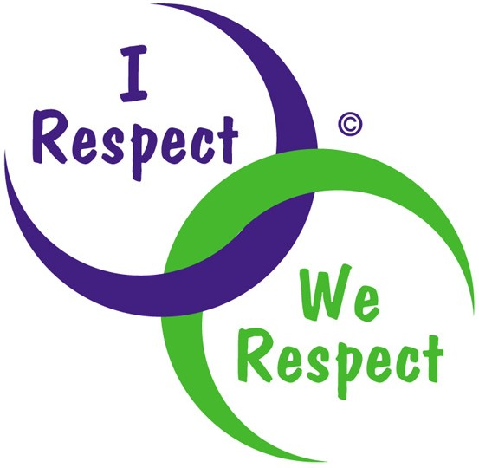
RESPECT. Respect yourself, your classmates, and your teacher. District policy states that harassment in or out of the classroom is not to be tolerated. Harassment based on race, ethnicity, able-bodiedness, sexuality, perceived sexuality, gender, gender expression, monetary standing, religion or faith-base, or any other factor will be reported to the administration and dealt with accordingly. This includes slang such as 'that’s so gay' or 'that’s retarded.' Both are considered hate speech.

Yes, I have read this intro handout. I understand the policies of the classroom, and if I ever have any questions I will call, email, or set up a time to meet with Ms. Harper. Detach and return by Sept 6.

Student name_________________________________________________________________

Student signature______________________________________________________________

Parent/Guardian name_________________________________________________________

Parent/Guardian signature_____________________________________________________

